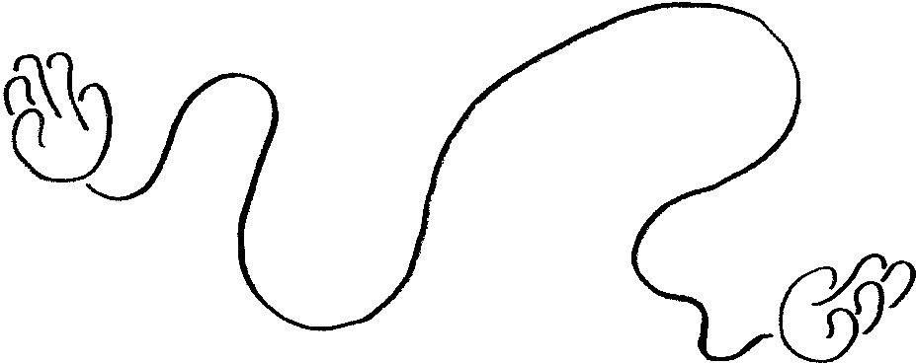


Derbyshire Makes – Glossop Hub Artist Brief
Derbyshire Makes seeks 3 artists from any creative discipline to lead public involvement in the Glossop Hub between February – April 2025. We are especially keen to hear from Glossop-based practitioners, or those with a Glossop connection.

Background
Derbyshire Makes is a new three-year programme to celebrate making in all its forms and shine a spotlight on the county’s extraordinary creative and cultural industries.
It also aims to nurture people’s creative potential and build new skills across the county for the future. Activities will include walks, talks, exhibitions, events, markets, hands-on workshops, a major digital commission, an annual festival and so much more. Touring activity will take place on the Makory mobile bus belonging to Derby's Museum of Making.

Glossop Hub
The Glossop Hub is being led by High Peak Community Arts, through a steering group of local and county groups and services. We are one of 6 hubs across the county, getting our own programme to plan collectively within the town.
The Hub will link to and enhance content from the countywide programme, animating the final 2 days (15th / 16th April) with new and existing creative work and activities for the public to take part in.

Artist’s brief
We are looking to commission 4 artist / creative ‘involvements’ which will produce content for the two day showcase in April. Each involvement must reach the public for inspiration and participation. The whole Derbyshire Makes programme is a public invitation to make, so we want these involvements to inspire and ignite a spark for continued making. One of the involvements is already confirmed to work with HPCA’s Film Cuts Club (a filmmaking club for young people with additional needs). We are open to cross-over between this and / or other involvements.

What artforms?
Any creative discipline is eligible to apply; Visual art, 3D, 2D, photography, film, digital, music, writing, dance, drama etc.

What outcomes?
The content for the final two days could be:
Finished work to exhibit / perform / screen
A participatory activity for the general public to try
A trail of content for the public to follow (think shop windows or similar)
A collaboration with one of the other involvements

Public participation
We will pair artists with a contact for participation, which could be a community group, a school, a local business or other.

Budget
Each involvement will have a budget of £3,000 for artist time, materials and production costs, to be agreed with HPCA at the start.

How to apply:
Send 6 - 10 images of your work / links to online content, and answer the following questions for your idea in either a 1-2 page proposal, or a 5 min video / audio file:
- Tell us about your primary artform, and if you use other artforms as well.
- What is your idea to get Glossop making?
- What activities would participants do? How many sessions would you run?
- What would the final content be for 15th/16th April?
- How would the budget break down?
- What experience do you have of working with groups and leading activities? In particular working with these age groups: Families with young children, primary aged children or adults who don’t usually engage in the arts.
- Do you have any existing contacts with groups / schools / businesses in Glossop?
- Would you be open to discussing cross-over with the other involvements when they are decided?
- Do you have a DBS certificate issued within the last 3 years?
- Are you available on or around the dates of 15th / 16th April 2025?
- If your proposal isn’t chosen, do you have existing work you would like to showcase in April? And would you need any budget to be able to display it effectively?

If you would like to discuss ideas before finalising a proposal, please contact sophie@highpeakarts.org. Please note I am on holiday between 18th December – 7th January, but will reply to messages as soon as I return.

Deadline for proposals is Monday 20th January
Shortlisting will take place Tuesday 21st January, and you may be invited to present your idea to the steering group in Glossop on Tuesday 28th January, tea time, exact time to be confirmed.

How we will choose the artists
We will balance the content suggested, so that the final 2 days offers a range for the general public including participatory experiences, artwork to see and performance. We will prioritise those based in the Glossop, or with a Glossop connection.
If your proposal isn’t chosen, we will also be offering the chance to showcase existing work, which there will be small budgets to present.

